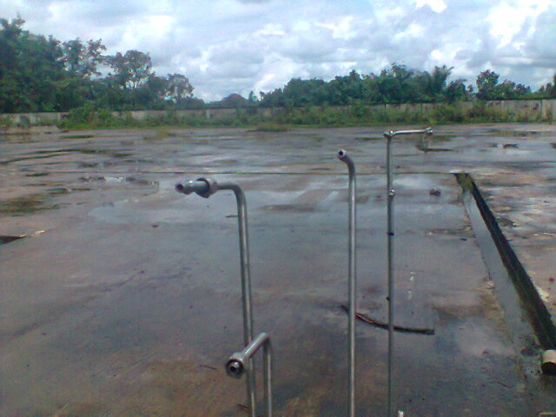
Picture showing the point from which the SSV was stolen from.
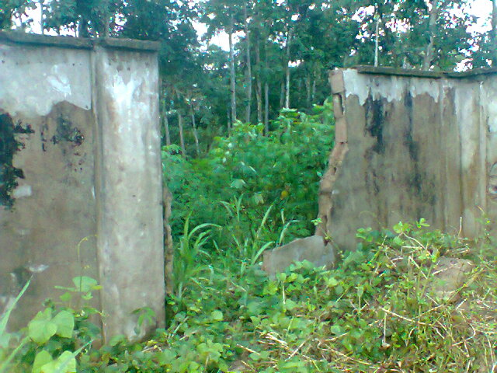
Picture showing broken fence of the wellhead area. ( Top and Bottom)
